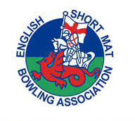
ESMBA 2024 SPECIAL GENERAL MEETING
Holiday Inn, Hinckley Road, Coventry, CV2 2HP
Saturday 20 July 2024

Chairman | Barry Hedges
General Secretary | Linda White
Treasurer | Simon Willies
Registration Secretary | Brian Baker
Competition Organiser | Nicky Tresadern
ICC Secretary | Steve Bailey
Coaching Director | Martin McGregor
Umpires Director | Brab Hallowes
Development Officer | James Scoins
IT and Social Media Officer | Rachel Hedges
Total Votes | 10
Delegates from Counties | 22
Grand total of votes | 32

1. The Chairman welcomed all those present and opened the Special General Meeting.

2. Apologies for Absence

Apologies had been received from Somerset, Brandon Whittaker and Lynn Dean.

3. Proposals

The Management Committee proposed additional wording to 3(j) to bring the clause in line with our safeguarding protocols.

For – 32 Against – 0 Abstentions – 0 Passed

The Special General Meeting was closed.

